CSA1103 00AD-LAB PRACTICE P.Gayathri(192321169)

Question 5: Student Course Registration System –Scenario: A university provides an online course registration portal. Students first create accounts and then select available courses. Registration remains pending until fee payment is completed. Once payment is verified, registration becomes confirmed. Students may withdraw before the semester starts. Courses may become full if seat limits are reached. Administrators can reopen registration if seats become available. Students receive notifications regarding status changes. The university wants to model the lifecycle of course registration
USE CASE DIAGRAM:
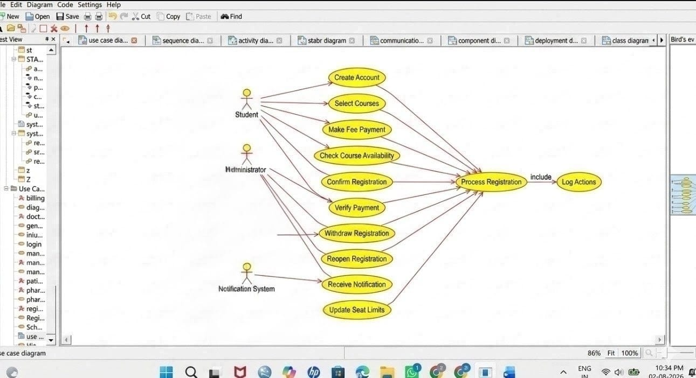
CLASS DIAGRAM:
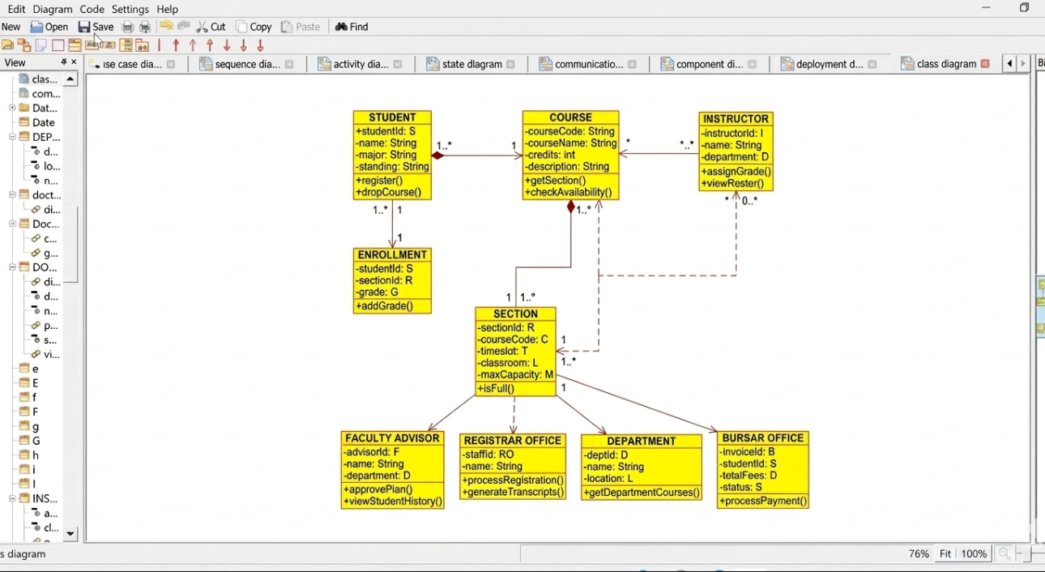

ACTIVITY DIAGRAM:
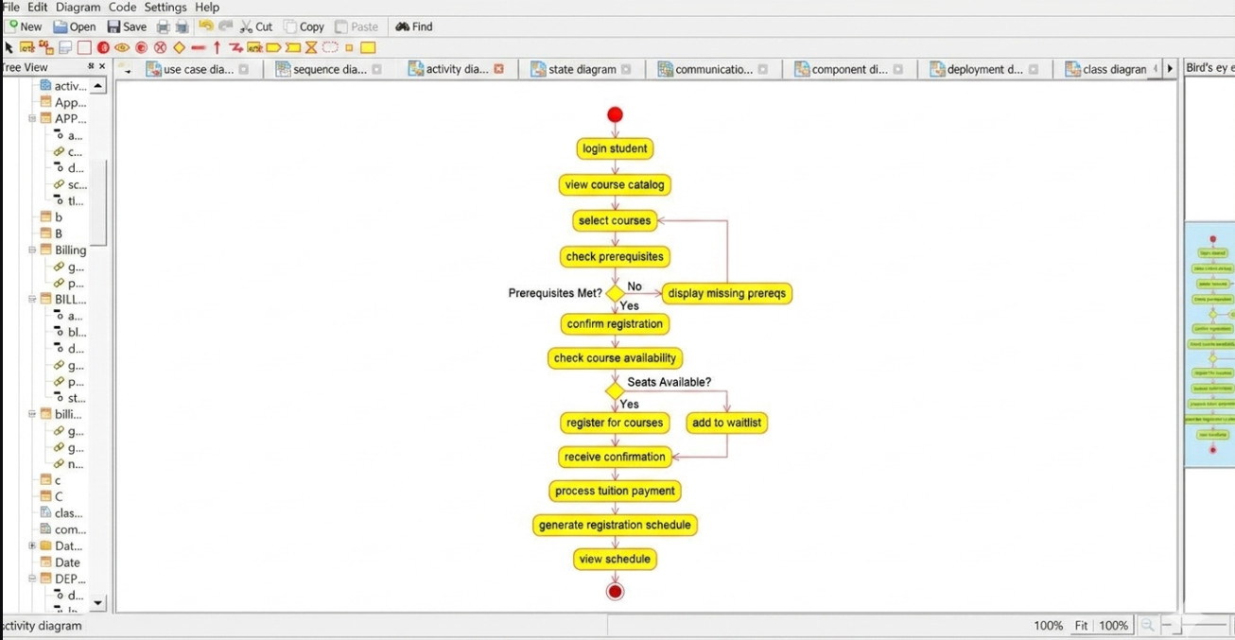
DEPLOYMENT DIAGRAM:
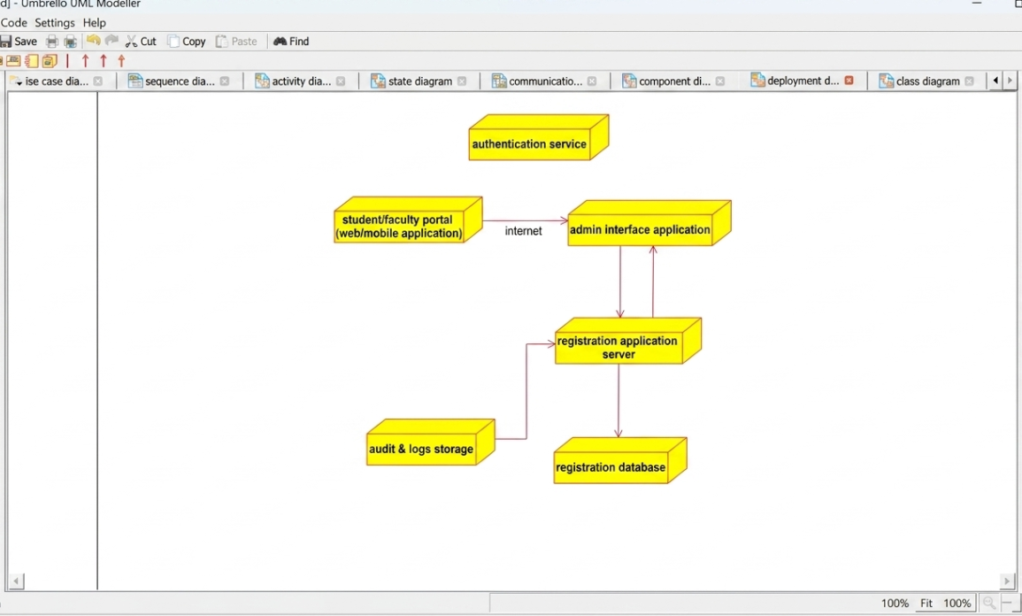

SEQUENCE DIAGRAM:
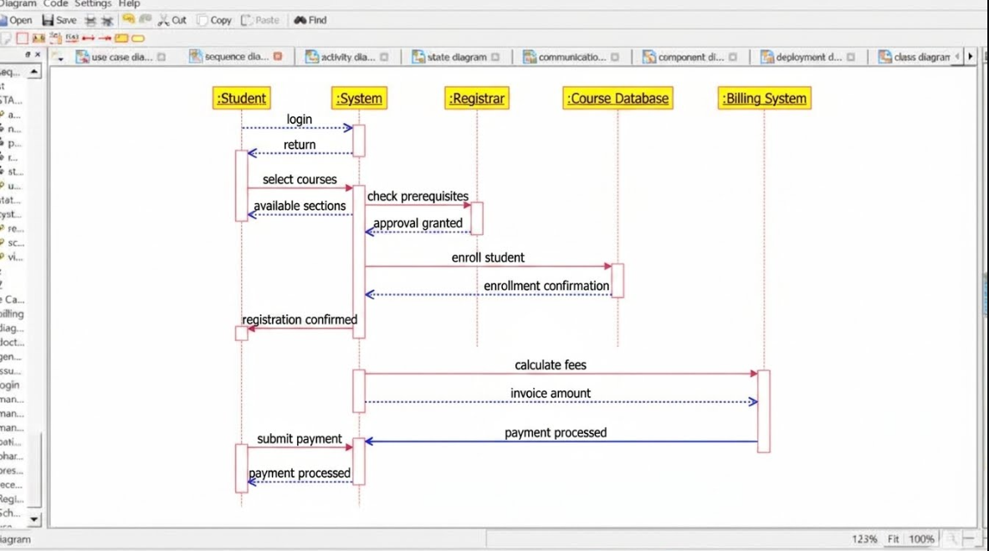

STATE MACHINE DIAGRAM:
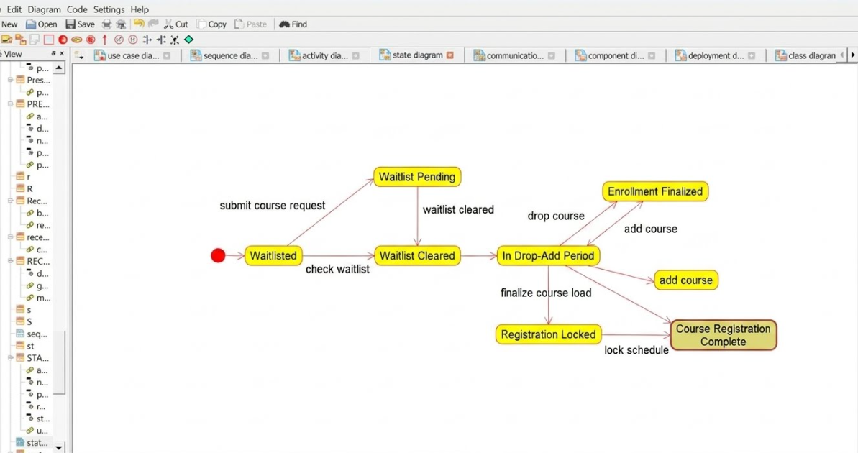

COMPONENT DIAGRAM:
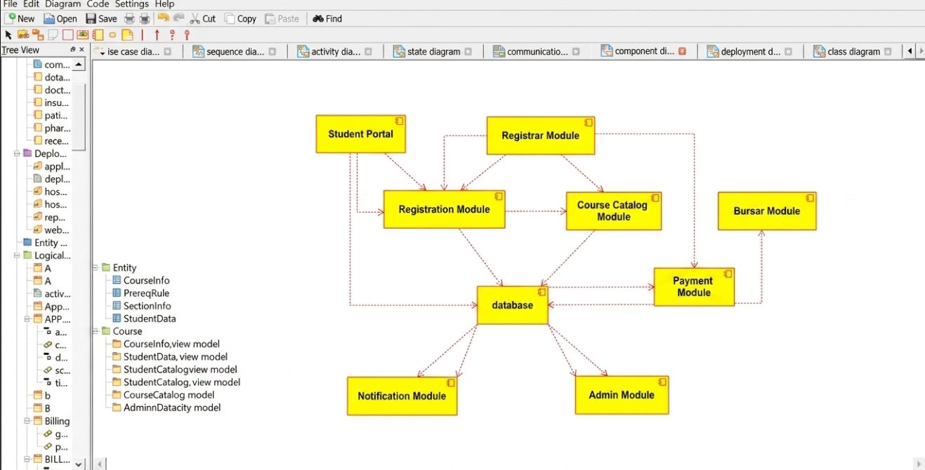
COMMUNICATION DIAGRAM:
